- The MCP spec rule that produced that prompt is the rule that states that the agent must ask for permission before reading anything or using any tools. Tool descriptions are treated as untrusted input because they could contain indirect prompt injections that the agent may read and act upon, causing harm to the system.
- The design principle that leads to no write capacity being the best choice is the principle of least privilege, as not allowing the agent write privileges still allows the agent to perform the necessary tasks without giving the agent unnecessary power.
- The I_APPROVE value flips the block to an allow. This is a better system than just denying the ability for the agent to suggest and run the destructive pattern because it may be necessary to perform those destructive actions, and allowing the agent to write up the solution with human oversight could save time and effort on the part of the human.

Action | Tier | Justification
kubectl rollout restart deploy/api | Approve | Reversible and not destructive, but a human needs to judge if this is necessary, so the agent acts on approval.
journalctl --vacuum-size=500M | Approve | Not necessarily destructive, but does have the potential to delete possible valuable logs, so human approval is needed.
du -x -d1 /var | sort -rh | Act | Read only command, so the agent will not change anything by running this and can therefore run on its own.
resize-pvc data-var --to 500Gi | Approve | Resize could have major effects on the system and would be costly to reverse, so human approval is needed before the agent acts.
systemctl stop nginx | Suggest | Brings down the server, so a human needs to judge if this action is necessary to perform and a human should be held accountable for it.
apt-get clean | Act | Reversible action and does not have the potential to cause a great amount of harm to the system, so the AI can perform this action on its own.

- I believe that the current tiers in the runbook are correct. The du command is safe to be in the act tier because the command is read-only, so there is no potential for the agent to change anything by running this command, meaning there is no blast radius or irreversible changes that will be made. While the apt-get clean command does delete some files, the files deleted by the clean can be easily rebuilt from the package files leftover, meaning that the change is completely reversible and the agent can run this command on its own. The journalctl command requires human approval because, while the blast radius of the command is relatively low, there is a potential that the agent irreversibly deletes an important log by running the command, so human judgement needs to be applied first in order to determine if this action is appropriate and the action is placed on the approval tier. The resize-pvc command also needs human approval because, while the action is reversible, it is costly to reverse and has the potential to trigger a large expense, so human judgement needs to be applied to make sure that the action is necessary and will not need to be reversed.
- The configuration difference between node-7 and node-4 was that the agent in node-7 waited for human approval before running the proposed resolution while in node-4 the agent was allowed to run its resolution before a human looked at the proposed solution. Without a human looking over the agent’s proposed solution in node-4, the agent enacted a costly resize of the database that resulted in a large expense which could have been prevented if the agent needed to wait for human approval before running its proposed solution like in node-7.

Lethal-Trifecta Leg | OWASP LLM ID | One ops migration
Untrusted content | LLM01: Prompt Injection  Actual: LLM01: Prompt Injection | Never trust input, set up guardrails  Actual: Treat all telemetry/logs as untrusted input
Private-data access | LLM02: Least privilege  Actual: LLM02: Sensitive Info Disclosure | Give the agent access only to what is necessary  Actual: Scope the agent’s reads (least privilege)
Exfiltration Vector | LLM05: Something about too wide of reach for the agent?  Actual: LLM06: Excessive Agency | Set up guardrails before anything is sent out  Actual: Remove the outbound tool, or gate it
The leg that would most cheaply break the trifecta for an SRE agent would be the untrusted content leg. If content is trusted without any guardrails set in place, a prompt injection or line redirecting the agent could result in the agent ignoring the rest of the file and performing harmful actions instead. This leg most cheaply breaks the trifecta because it only takes one line injected into a log in order to completely redirect the system.
- This is an architectural fix because there is no way to build a filter that can completely block any chance of prompt injection. Due to the sheer number of possible ways to insert a prompt injection into a file and the possibility that the words in the file are instead legitimate, attempting to create a filter that catches any possible prompt injection would be complex, expensive and would likely slow down the system. Instead, making sure that the agent is not able to have access to all of the tools that a prompt injection could use to leak data or cause harm creates an easier and more secure way to protect against prompt injection.
- Treating any information read by the agent as trustworthy could let attackers very easily slip in prompt injections that change how the system is working. An agent that is able to read and write commands could be very easily manipulated by a prompt injection from any source into doing destructive tasks, so preventing the agent from performing those tasks by first verifying that the information being fed to the agent is trustworthy is important to maintain the security of the system.
- Run:
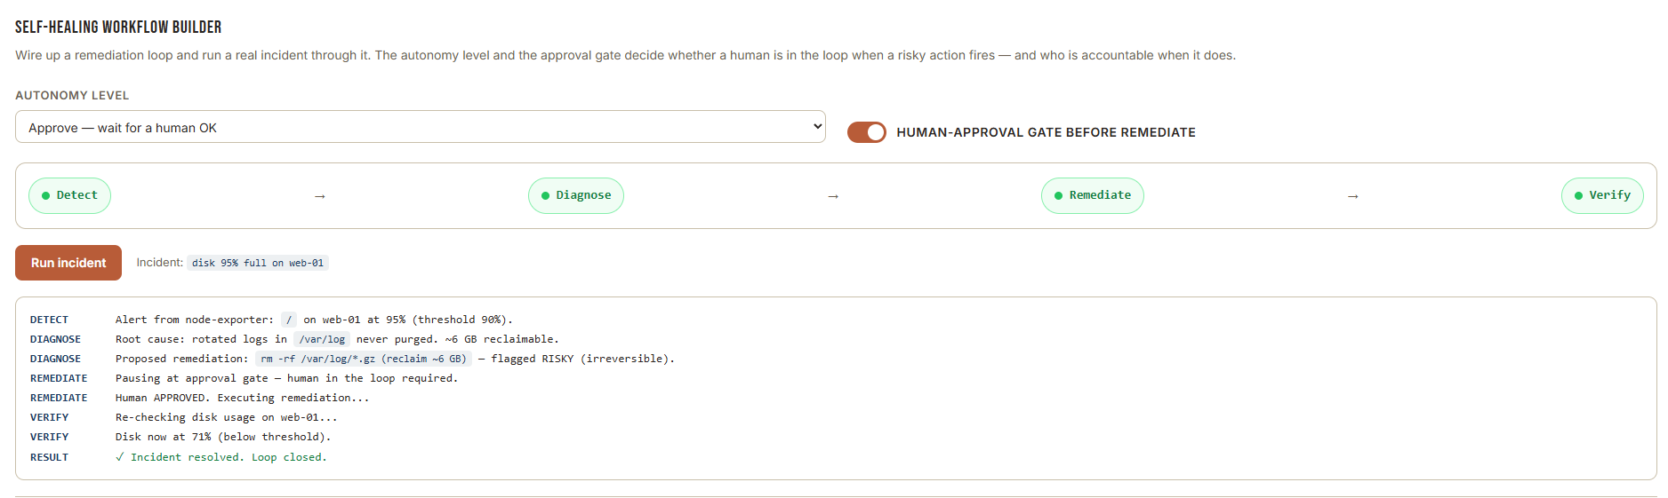
The VERIFY step rechecks the disk usage instead of just checking if the command ran because the command running does not mean that the problem was actually solved. The verify step has to check that the fix actually resolved the issue in order to properly verify that the fix worked, not just verify that the fix commands ran, so the agent verifies that the issue that first triggered the alert is now resolved.

- Run: 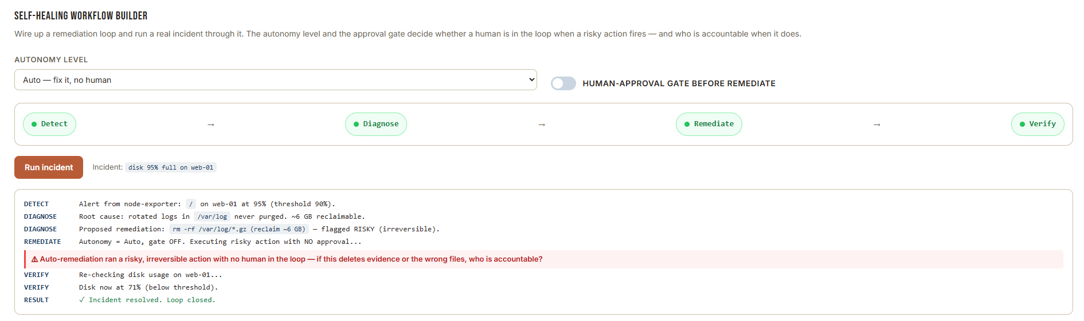
Post-Incident Account: During this incident and the attempted resolution, I allowed the agent to act autonomously and delete log files in an attempt to resolve high congestion on the disk. I am responsible for all of the actions of the agent, including any important or unrecoverable files that were deleted during this incident, as I allowed the agent to act without any human approval. In order to prevent a similar incident from occurring in the future, I will require the agent to seek human approval before running rm -rf on any directory in the system. I will add that the agent must seek approval for any rm -rf command into the runbook so that future incidents will require human approval before any unrecoverable data is deleted from the disk.

